**FOR IMMEDIATE RELEASE** **Contact:** Joane Cunningham

**Phone:** 812-663-3342

**Email:** unitedfunddc@etczone.com

**United Fund Awards $49,480 in Special Grants**

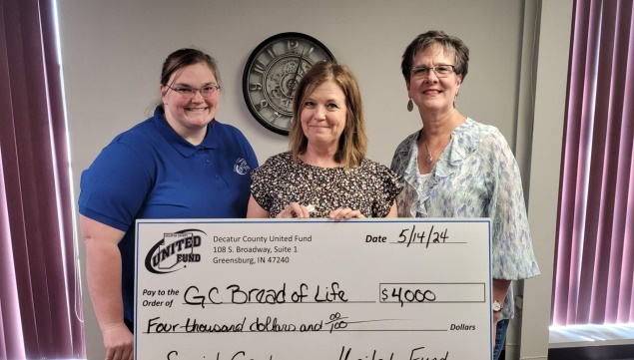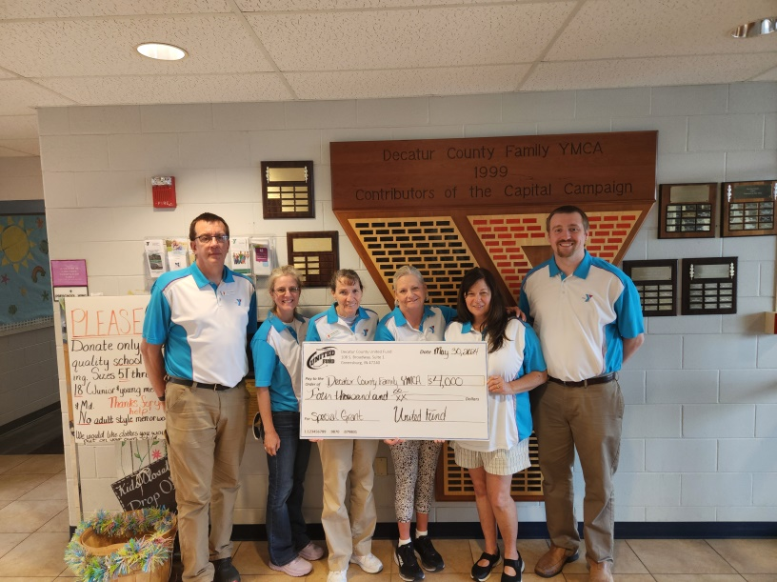

[Greensburg, IN May 23, 2024—] The United Fund awarded $49,480 in special grants to 14 of their current community partners at its recent Board of Director’s meeting. This is another way the United Fund invests in the community, through special grants to meet specific needs and support special projects. The 2024 special grants were awarded due to the success of the 2023 campaign.

These grants fund short-term projects or one-time expenses that will have a positive impact in the community. Joane Cunningham, Executive Director, shared, “Having exceeded campaign goal means we can further assist each of our agencies. Those agencies are eligible to receive up to $4,000. With reduction in funding a constant battle for many, this is beneficial to many non-profits that applied for the special grants.”

The 2024 Special Grant recipients are:

**Advocates for Children:** $4,000 mileage reimbursement in Decatur County for staff Guardian Ad Litem and CASA (Court Appointed Special Advocate) to visit children in their foster homes and other placements;  
**Carousel Play and Learn Center:** $4,000 for rubber mulch for outdoor playground to meet Indiana requirements and permanent mulch;  
**Catch a Ride:** $4,000 to help with fuel purchases in Decatur County;   
**Champions of Youth:** $4,000 help cover salary expenditures;  
**Children’s Advocacy Center:** $4,000 to support the Education Prevention Program in the Greensburg schools k-12 grades;  
**Community Healthcare Clinic:** $4,000 to help cover monthly rent;

**Girl Scouts:** $4,000 for Service Unit event in Decatur County;  
**Greensburg Community Bread of Life:** $4,000 to help cover salaries;  
**Head Start:** $3,038 to purchase additional educational materials  
**Human Services:** $4,000 to purchase food for food pantry;  
**Our Hospice:** $3,745 to purchase a Virtual Dementia Tour (VDT) Trainer instruction and tool box;  
**Speranza House:** $1,197 to fix the Central Avenue location roof;  
**Turning Point: $**1,500 for client assistance in their Emergency Residential Shelter or   
non-residential programming;  
**Decatur County YMCA:** $4,000 matching dollars towards roof repairs.

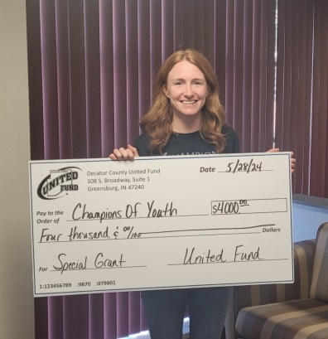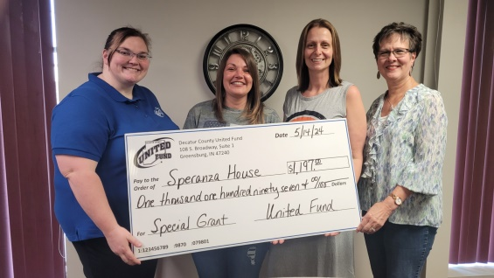

This funding is in addition to the regular community investment/allocation given to the funded partners of the Decatur County United Fund.

To continue the valued work of the agencies, individuals and businesses can give to the United Fund anytime throughout the year by simply mailing a check to the United Fund or by visiting their website at [www.dcuf.com](http://www.dcuf.com) and select the green “Give Now” at the top of the page. The mailing address is: 108 S. Broadway, Suite 1, Greensburg, IN 47240.

If you would like more information about this topic, please call Joane Cunningham at 812-663-3342, email [unitedfunddc@etczone.com](mailto:unitedfunddc@etczone.com) or visit our website at [www.dcuf.com](http://www.dcuf.com) .

xxx