For Immediate Release Joane Cunningham, 812-663-3342

August 19, 2024 Decatur County United Fund

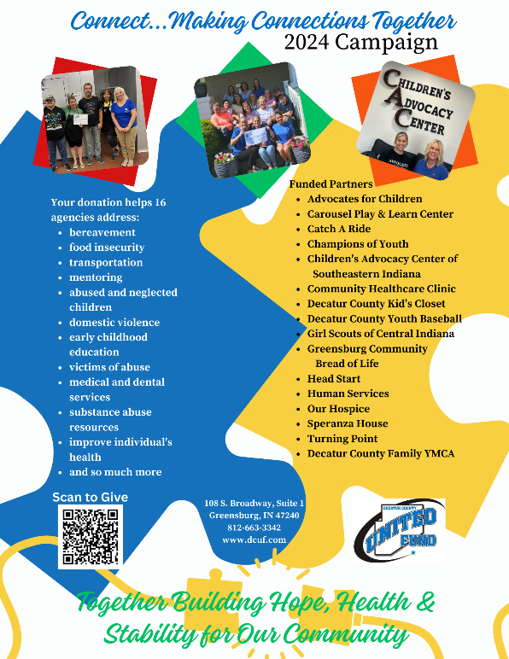

2024 UNITED FUND CAMPAIGN Making Connections Together

The Decatur County United Fund is pleased to announce the 2024 campaign is underway and will soon be conducting this year’s fundraising efforts in the “Making Connections Together” campaign. This year’s goal is $555,000.

Joane Cunningham, Executive Director of the United Fund, stated, “The Decatur County United Fund mobilizes a single fundraising campaign to raise money for a diverse range of nonprofits serving Decatur County. Each February, 501c3 health and human service nonprofit agencies can apply to the United Fund for funding for the following year. The Community Investment Committee reviews applications and interviews the agencies that are requesting funding. After completing all nonprofit agency reviews, the Community Investment Committee gives thorough consideration as to community need in preparing its recommendation to the Board.”

The 2024 campaign dollars will support 16 agencies and 20 programs in 2025. They include Advocates for Children, Catch-A-Ride, Champions of Youth, Children’s Advocacy Center of Southeastern Indiana, Greensburg Community Bread of Life, Carousel Play and Learn Center, Community Healthcare Clinic, Decatur County Kids Closet, Decatur County Youth Baseball, Girl Scouts, Human Services Food Pantry and Head Start, Our Hospice of Decatur County, Speranza House, Turning Point, and Decatur County Family YMCA.

“We appreciate everyone’s support and the support of the entire county when it comes to making sure our health and human services agencies are here to do just that—serve the human needs of our community. United Fund dollars are very important for our funded partners to meet budgetary program needs, ” noted Cunningham.

Cunningham shared, “We ask that the community consider giving one of several ways. Company campaigns are a great way to support the work of the United Fund and the many agencies they serve. If available, payroll deduction is the simplest way to pledge to the United Fund. Donations can also be mailed to the Decatur County United Fund at 108 S. Broadway, Suite 1, Greensburg, IN 47240. You can also pledge online on our Facebook page or visit [www.dcuf.com](http://www.dcuf.com) and “DONATE” on our website at any time. Follow the simple instructions. A QR code is on our marketing materials and website – utilize your phone, scan and follow the simple steps.”

The 2024 campaign goal is $555,000 and is currently at $140.901 or 25.3% of goal.

Decatur County United Fund has been in operation since 1957; celebrating our 67th year of community work in 2024. Our mission is Together Building Hope, Health & Stability for Our Community. Our vision is to improve the quality of life for the people of Decatur County, especially the most vulnerable. Increase human and capital resources available to support our community partner’s efforts to address community-wide goals. Serve as a community leader developing and leveraging diverse, collaborative partnerships to impact health and human services outcomes. For more information, contact Joane Cunningham, Executive Director at unitedfunddc@etczone.com.

xxx